SERVERLESS FRAMEWORK ASSIGNMENT

**Team: Spartans**

**Members:**

Sanjay Bhargav Madamanchi

Abdul Vahed Shaik

Chirudeep Gorle

Jayanth Vishal Reddy Godi

Sai Pragna Kancheti

Github Link: <https://github.com/ChirudeepG/CMPE272_Serverless-Framework.git>

Creating a IAM role

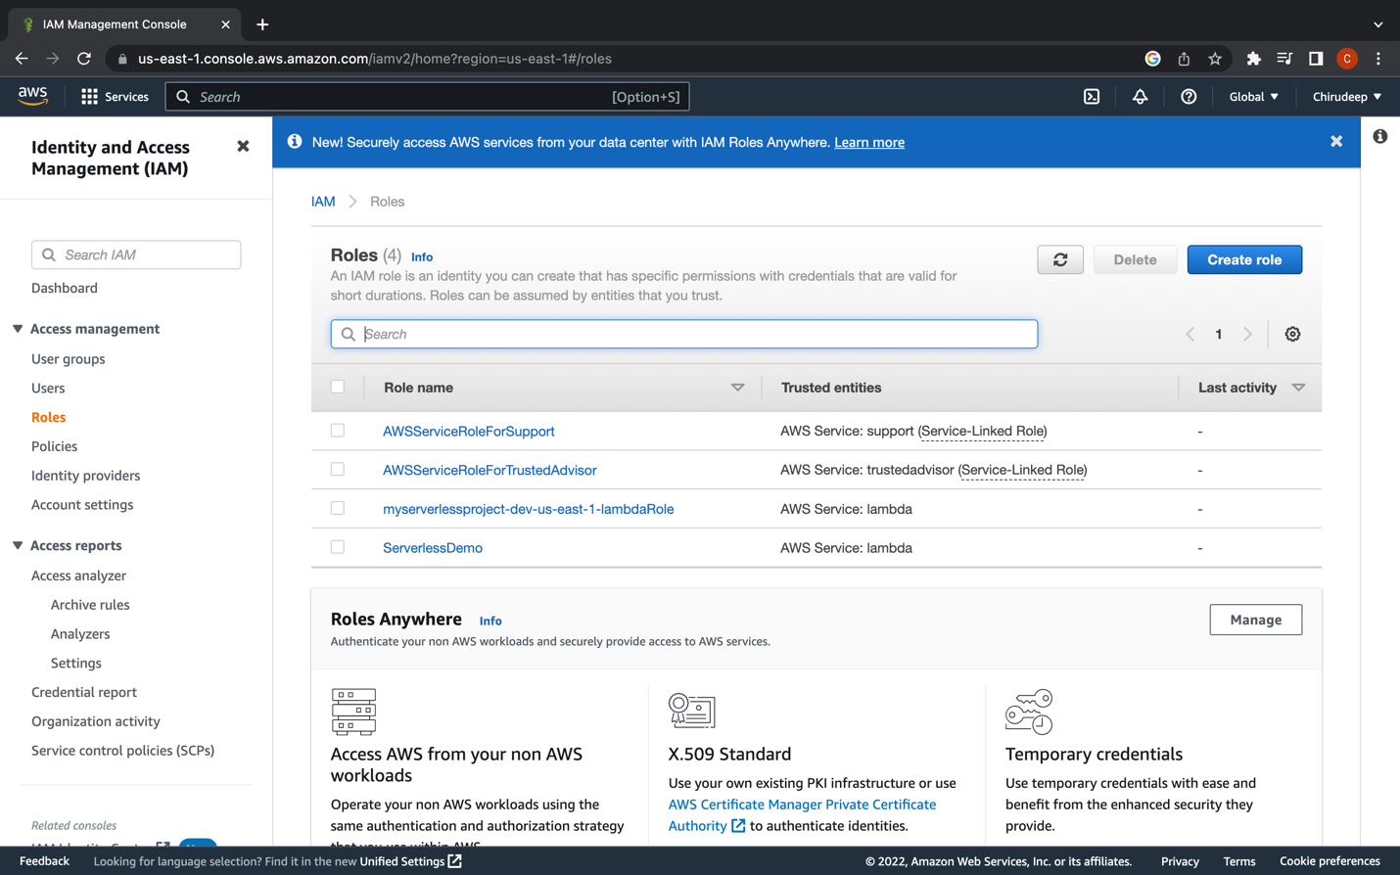

Creating IAM User

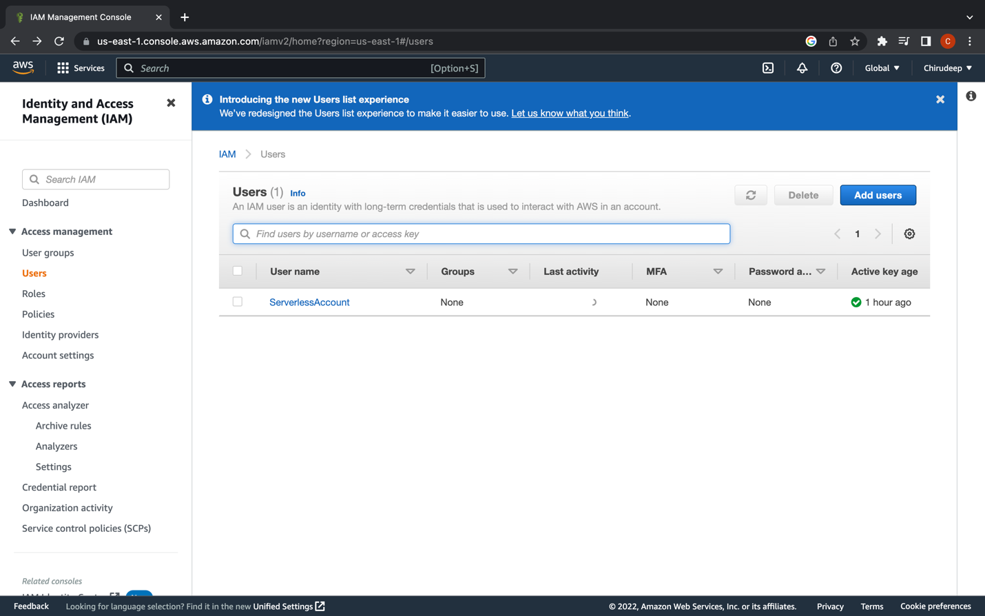

Installing Serverless and version check

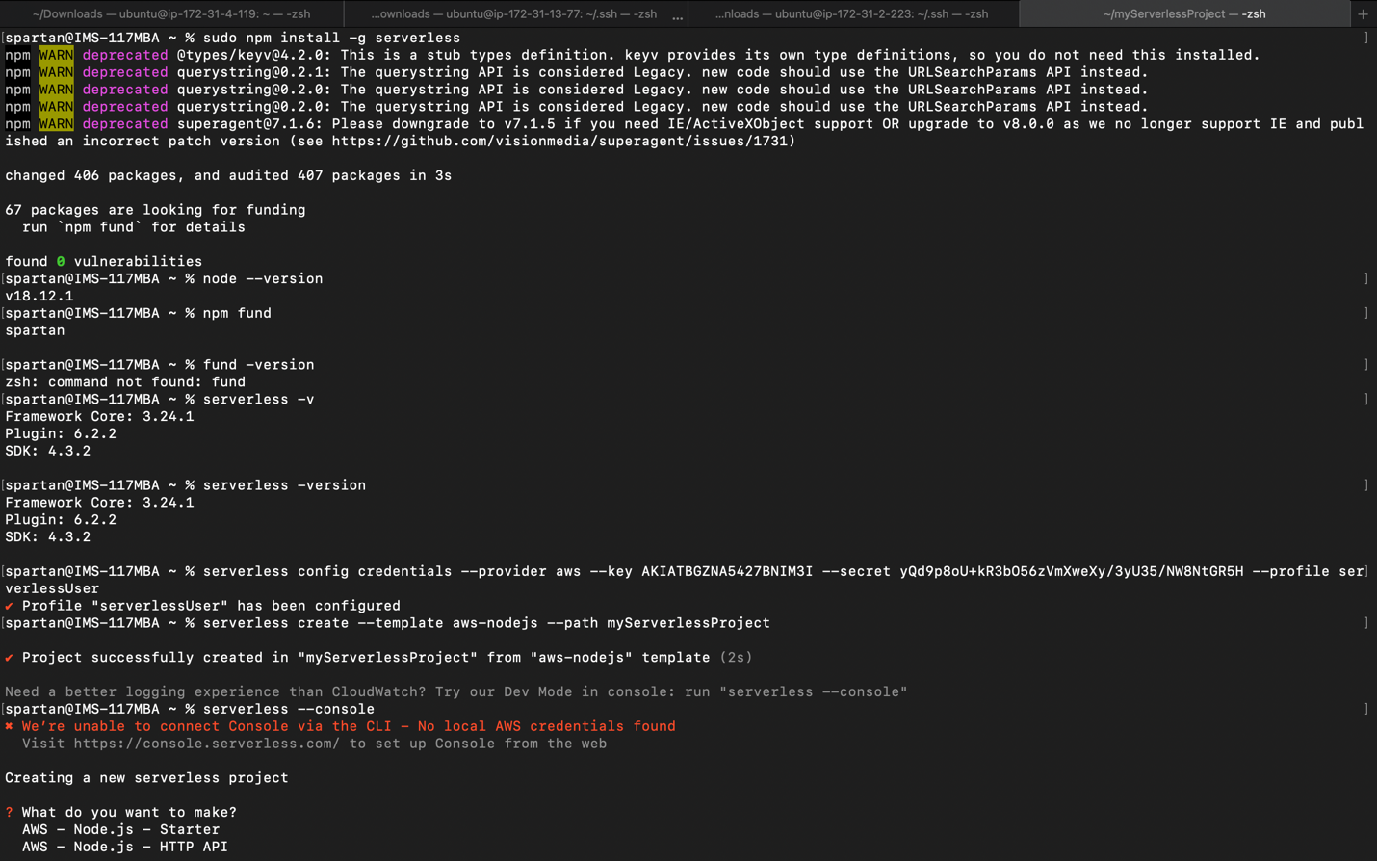

Code

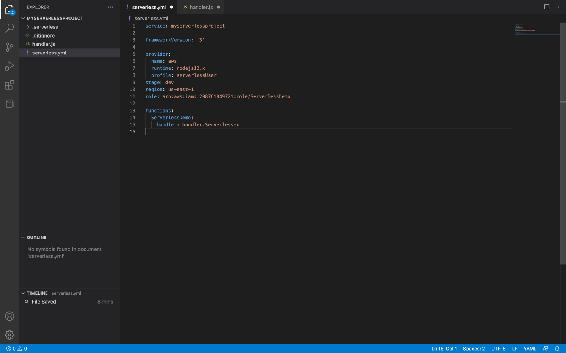

\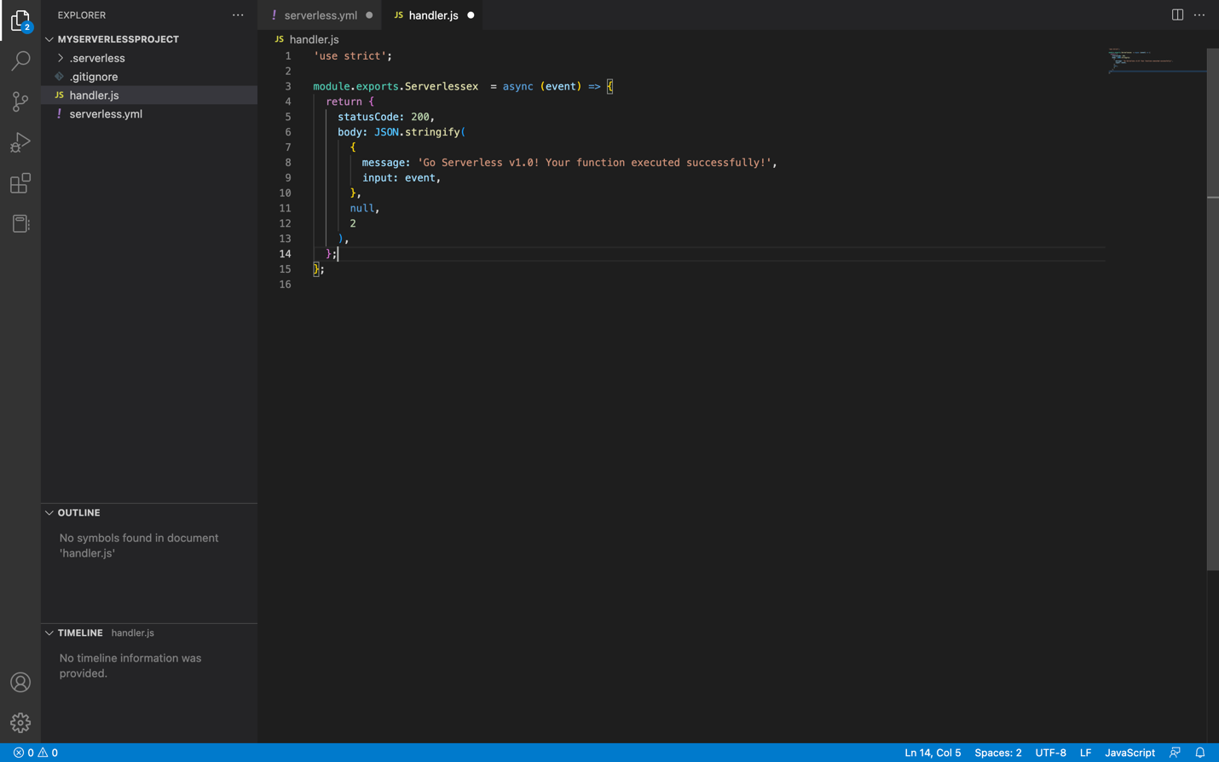

Deploying

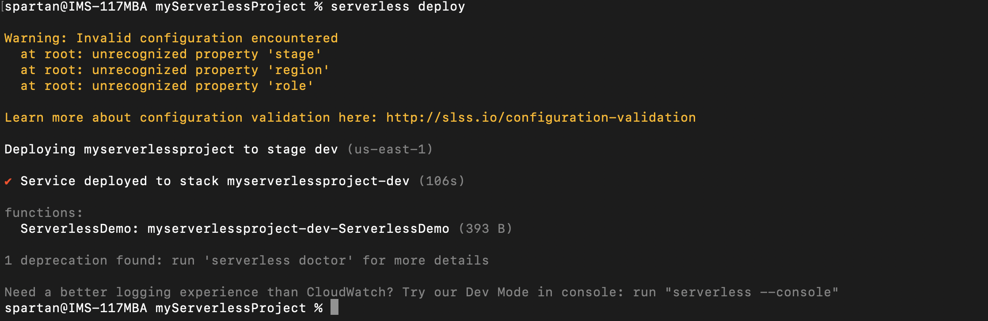

After Deploying

